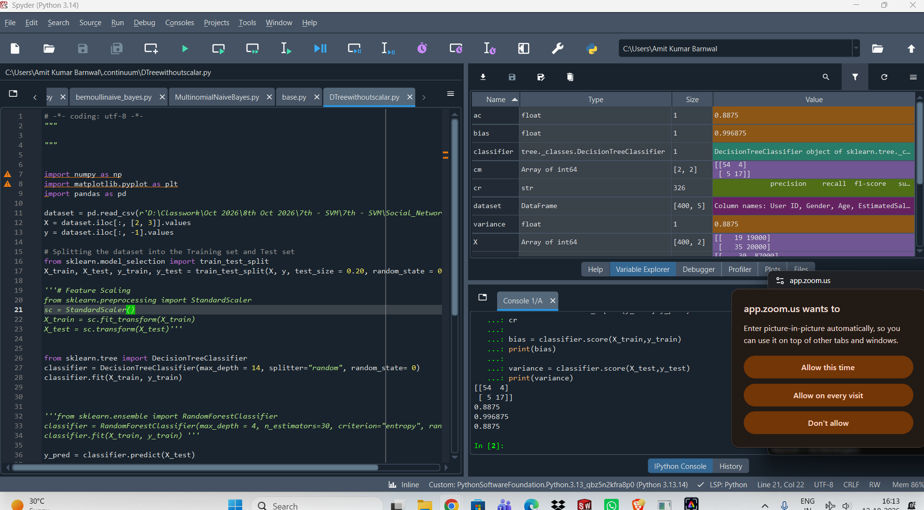
Decision Tree without Scaling Features
Accuracy = 88.75, Bias = 99.68, Variance = 88.75
Decision Tree with Scaling Features
Accuracy= 90, Bias= 99.68, Variance = 90
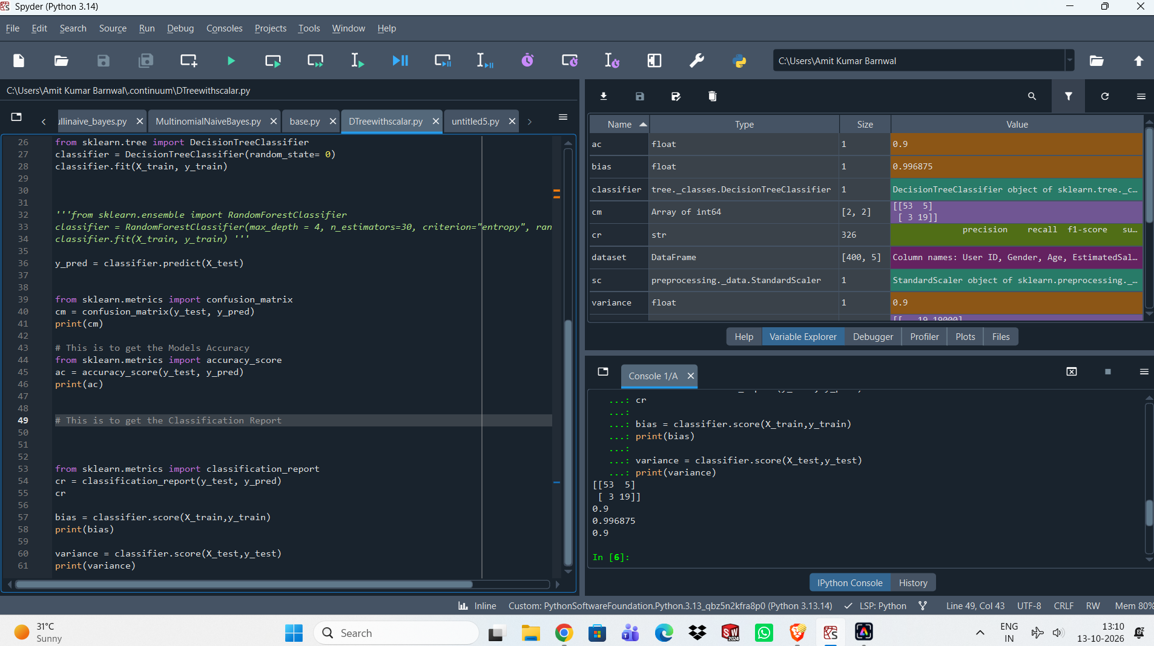
- from sklearn.tree import DecisionTreeClassifier
classifier = DecisionTreeClassifier(random_state=0)
classifier.fit(X_train, y_train)
Accuracy= 90, Bias= 99.68, Variance = 90

- from sklearn.tree import DecisionTreeClassifier
classifier = DecisionTreeClassifier()
classifier.fit(X_train, y_train)
Accuracy= 91.25, Bias= 99.68, Variance = 91.25
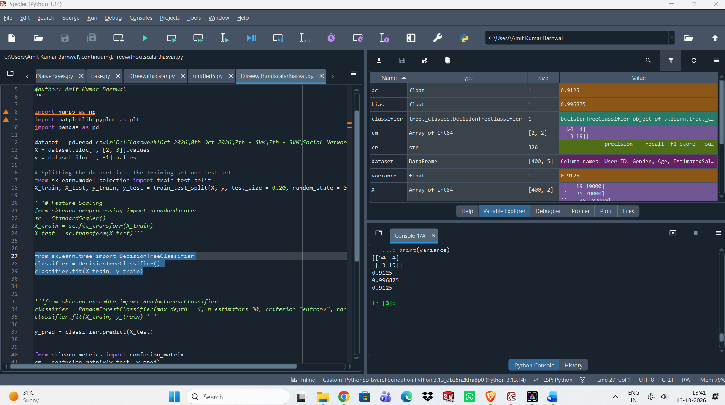
- 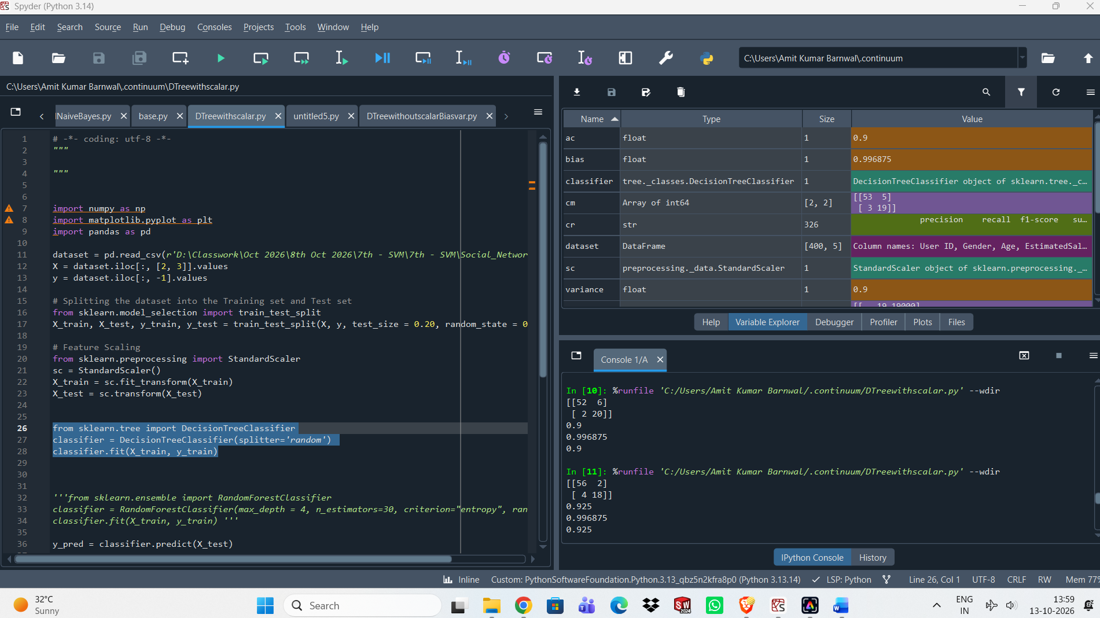
from sklearn.tree import DecisionTreeClassifier
classifier = DecisionTreeClassifier(splitter='random')
classifier.fit(X_train, y_train)
Accuracy= 92.5, Bias= 99.68, Variance = 92.5

- from sklearn.tree import DecisionTreeClassifier
classifier = DecisionTreeClassifier(max_depth=10, splitter='random', random_state=0)
classifier.fit(X_train, y_train)
Accuracy= 93.75, Bias= 99.68, Variance = 93.75

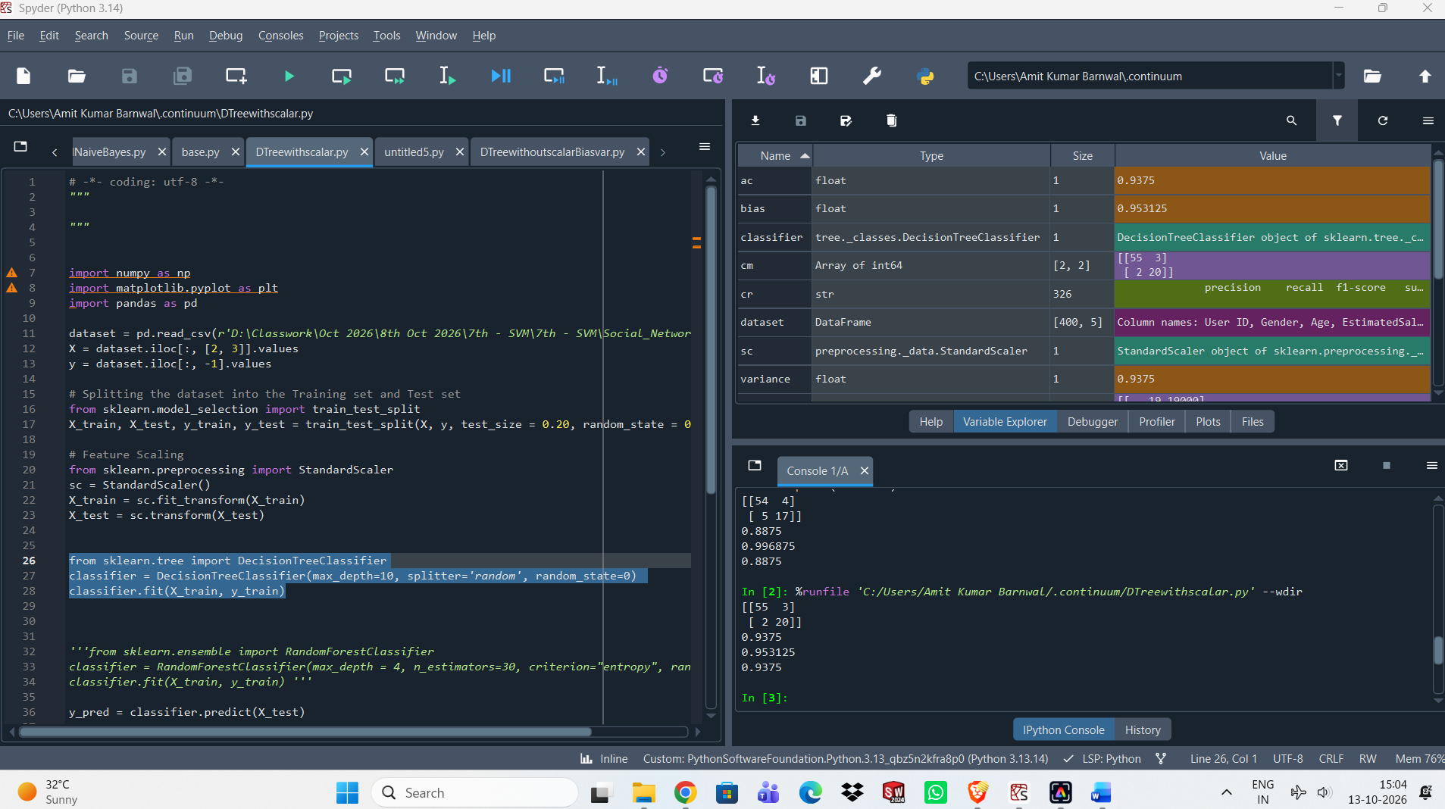

Random Forest with Scalar Features

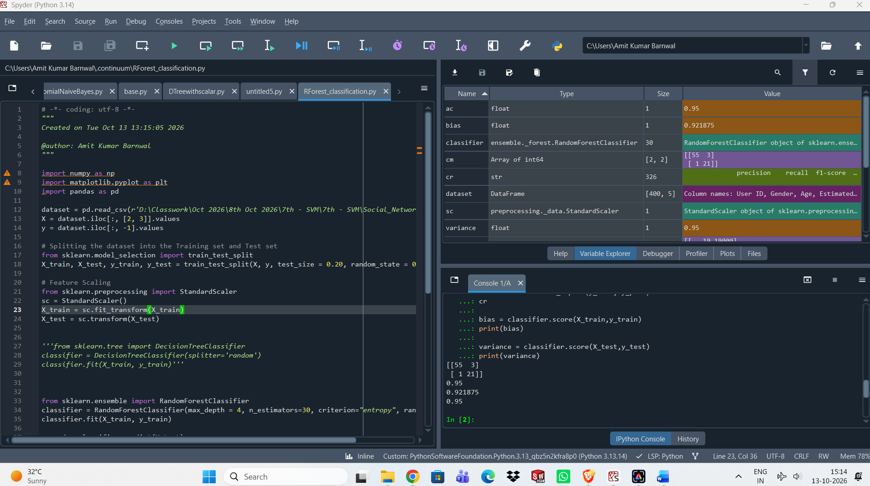
Accuracy = 95, Bias = 92.18, Variance = 95
from sklearn.ensemble import RandomForestClassifier
classifier = RandomForestClassifier(max_depth = 4, n_estimators=30, criterion="entropy", random_state = 0)
classifier.fit(X_train, y_train)

